API Design document

1. Database diagram
ER diagram of the schema: tables, columns (with types), primary and foreign keys, and the relationships between them.
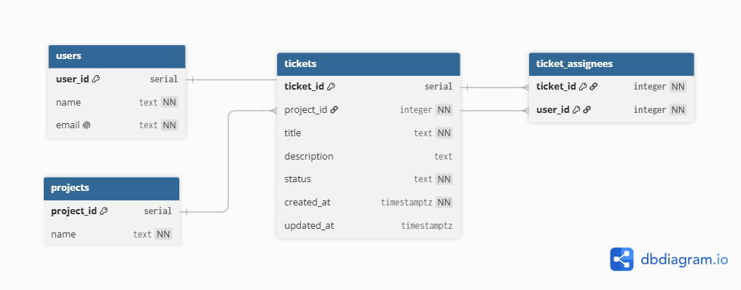

2. Endpoint summary

Method | Path | Description
POST | /api/users | Create a new user
PUT | /api/users/{id} | Update an existing user
DELETE | /api/users/{id} | Delete a user
GET | /api/users | List all users
GET | /api/users/{id} | Get a single user
GET | /api/projects | List all projects (with per-status counts)
POST | /api/tickets | Create a new ticket
PUT | /api/tickets/{id} | Update a ticket
POST | /api/tickets/{id}/assignees | Add an assignee
DELETE | /api/tickets/{id}/assignees/{userId} | Remove an assignee
GET | /api/tickets/{id} | Get a single ticket
GET | /api/tickets?search=...&status=... | Search tickets

3. Endpoint description

POST /api/users
Create a new user

Endpoint | /api/users
Method | POST
Request body | {  "name": "string",  "email": "string"  }
Response body | {  "id": "integer",  "name": "string",  "email": "string"  }
Validations | - The request must contain email and name fields.  - Email should have ‘@’ sign somewhere in the string.  - Name should be at least 3 characters long  - There is no other user with the same email.

PUT /api/users/{id}
Update an existing user

Endpoint | /api/users/{id}
Method | PUT
Request body | {  "name": "string",  "email": "string"  }
Response body | {  "id": "integer",  "name": "string",  "email": "string"  }
Validations | 1. The request must contain email and name fields.  2. Email should have ‘@’ sign somewhere in the string.  3. Name should be at least 3 characters long  4. There is no other user with the same email.  5. User {id} must exist

DELETE /api/users/{id}
Delete a user

Endpoint | /api/users/{id}
Method | DELETE
Request body | none
Response body | none
Validations | User {id} must exist

GET /api/users
List all users

Endpoint | /api/users
Method | GET
Request body | none
Response body | List of {id, name, email}
Validations | none

GET /api/users/{id}
Get a single user

Endpoint | /api/users/{id}
Method | GET
Request body | none
Response body | id, name, email
Validations | User {id} must exist

GET /api/projects
List all projects (with per-status counts)

Endpoint | /api/projects
Method | GET
Request body | none
Response body | List of { id, name, ticketCounts: { open, in progress, closed } }
Validations | none

POST /api/tickets
Create a new ticket

Endpoint | /api/tickets
Method | POST
Request body | title, description(optional), projectId, status
Response body | id, title, description, projectId, status, createdAt, updatedAt(null), assignees([])
Validations | 1. title required  2. status must be open | in progress | closed  3. projectId must exist

PUT /api/tickets/{id}
Update a ticket

Endpoint | /api/tickets/{id}
Method | PUT
Request body | title, description, projectId, status (full ticket; id in the URL)
Response body | Full updated ticket (updatedAt now set)
Validations | 1. same rules as create  2. ticket {id} must exist  3. projectId must exist

POST /api/tickets/{id}/assignees
Add an assignee

Endpoint | /api/tickets/{id}/assignees
Method | POST
Request body | userId (ticket id is in the URL)
Response body | Ticket with updated assignee list
Validations | 1. ticket must exist  2. user must exist  3. user not already assigned

DELETE /api/tickets/{id}/assignees/{userId}
Remove an assignee

Endpoint | /api/tickets/{id}/assignees/{userId}
Method | DELETE
Request body | none
Response body | none
Validations | 1. Ticket must exist  2. that assignment must exist

GET /api/tickets/{id}
Get a single ticket

Endpoint | /api/tickets/{id}
Method | GET
Request body | None (id is in the URL)
Response body | Full ticket – id, title, description, projectId, status, createdAt, updatedAt, assignees
Validations | Ticket {id} must exist

GET /api/tickets?search=...&status=...
Search tickets

Endpoint | /api/tickets?search=...&status=...
Method | GET
Request body | none
Response body | List of tickets ([] if none match)
Validations | 1. If status given, it must be a valid value  2. no filters → return all tickets

4. Email notifications
- When→ Every time a ticket changes: on PUT (title/description/status/project), on add-assignee, and on remove-assignee. Not on ticket creation.
- Who → The ticket's assignees after the change is applied. Removed users do not get it; newly added ones do. If there are zero assignees, send nothing.
- What → To which ticket, what happened, what is the title and status, and the assignee names.
- What happens if sending fails → Save the ticket first and return success, then send mail inside a try/catch. Never rethrow — log error with the ticket id and recipient so the failure is traceable. Credentials come from env variables.

